**RIDHO SURYA / 1710031802135**

**ALGORITMA & PEMOGRAMAN**

Program 4.1 if_nilai

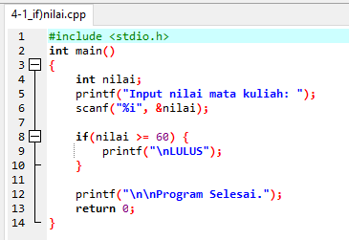

|  |  |
| --- | --- |
| Nilai | Keluaran |
| 80 | Lulus |
| 100 | Lulus |
| 40 | Program Selesai. |
| 50 | Program Selesai. |

|  |  |
| --- | --- |
| Nilai | Keluaran |
| 60 | Lulus |
| 61 | Lulus |
| 150 | Lulus |
| - | Program Selesai. |

Program 4.2 ifelse_nilai

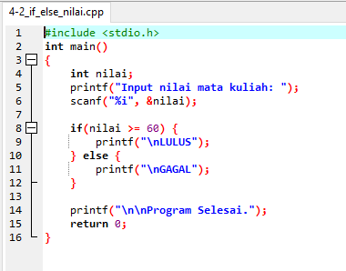

|  |  |
| --- | --- |
| Nilai | Keluaran |
| 80 | Lulus |
| 100 | Lulus |
| 40 | Gagal |
| 50 | Gagal |

|  |  |
| --- | --- |
| Nilai | Keluaran |
| 60 | Lulus |
| 61 | Lulus |
| 150 | Lulus |
| - | Gagal |

Program 4.3 ifelse_nilai_cara2

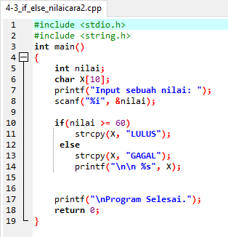

|  |  |
| --- | --- |
| Nilai | Keluaran |
| 80 | Lulus |
| 100 | Lulus |
| 40 | Gagal |
| 50 | Gagal |

|  |  |
| --- | --- |
| Nilai | Keluaran |
| 60 | Lulus |
| 61 | Lulus |
| 150 | Lulus |
| -80 | Gagal |

Program 4.4 ifelse_nilai_cara3

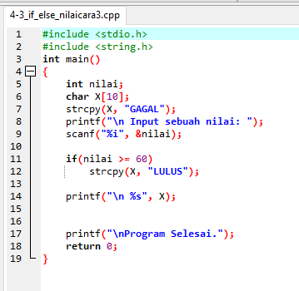

|  |  |
| --- | --- |
| Nilai | Keluaran |
| 80 | Lulus |
| 100 | Lulus |
| 40 | Gagal |
| 50 | Gagal |

|  |  |
| --- | --- |
| Nilai | Keluaran |
| 60 | Lulus |
| 61 | Lulus |
| 150 | Lulus |
| -80 | Gagal |

Program 4.5 ifelse_grade

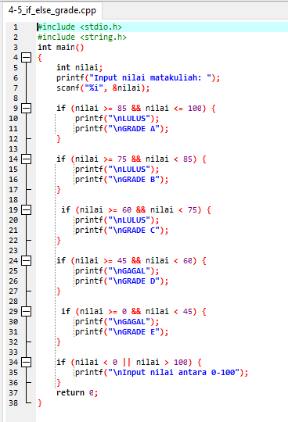

|  |  |
| --- | --- |
| Nilai | Keluaran |
| 80 | Lulus / Grade B |
| 100 | Lulus / Grade A |
| 40 | Gagal / Grade E |
| 50 | Gagal / Grade D |

|  |  |
| --- | --- |
| Nilai | Keluaran |
| 60 | Lulus / Grade C |
| 61 | Lulus / Grade C |
| 150 | Input nilai antara 0-100 |
| -80 | Input nilai antara 0-100 |

Program 4.6 terbesar_cara2

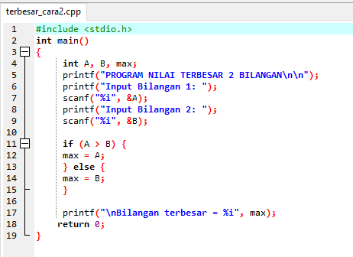

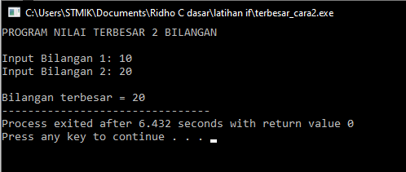

2. Buatlah program bahasa C berdasarkan beberapa flowchart / algoritma berikut ini!

Flowchart 1

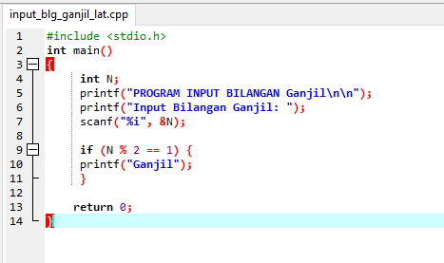

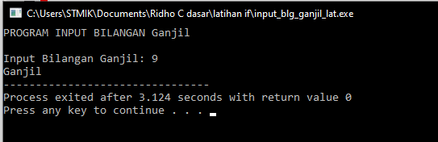

Flowcart 2

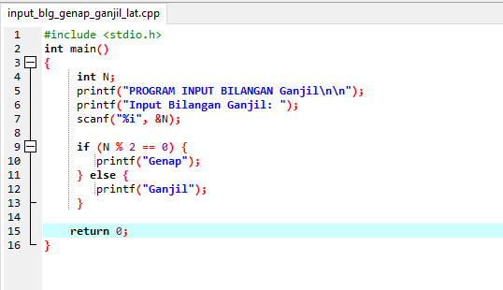

Tugas Mandiri

Perhatikan flowchart pada Gambar 2

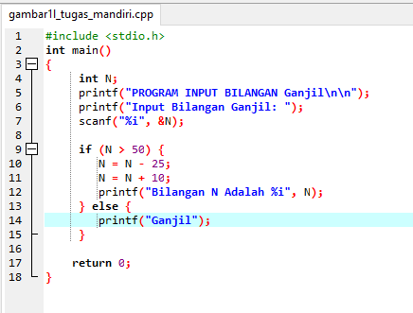

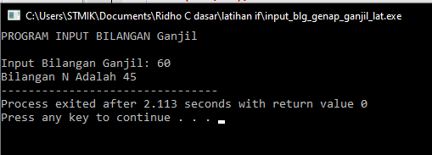

|  |  |
| --- | --- |
| Nilai | Keluaran |
| 30 | Keluar Dari Statement |
| 50 | Keluar Dari Statement |
| 65 | 50 |

Perhatikan flowchart pada Gambar 1

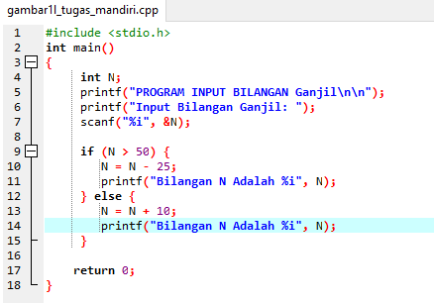

|  |  |
| --- | --- |
| Nilai | Keluaran |
| 30 | 40 |
| 50 | 60 |
| 65 | 40 |

Terima Kasih.